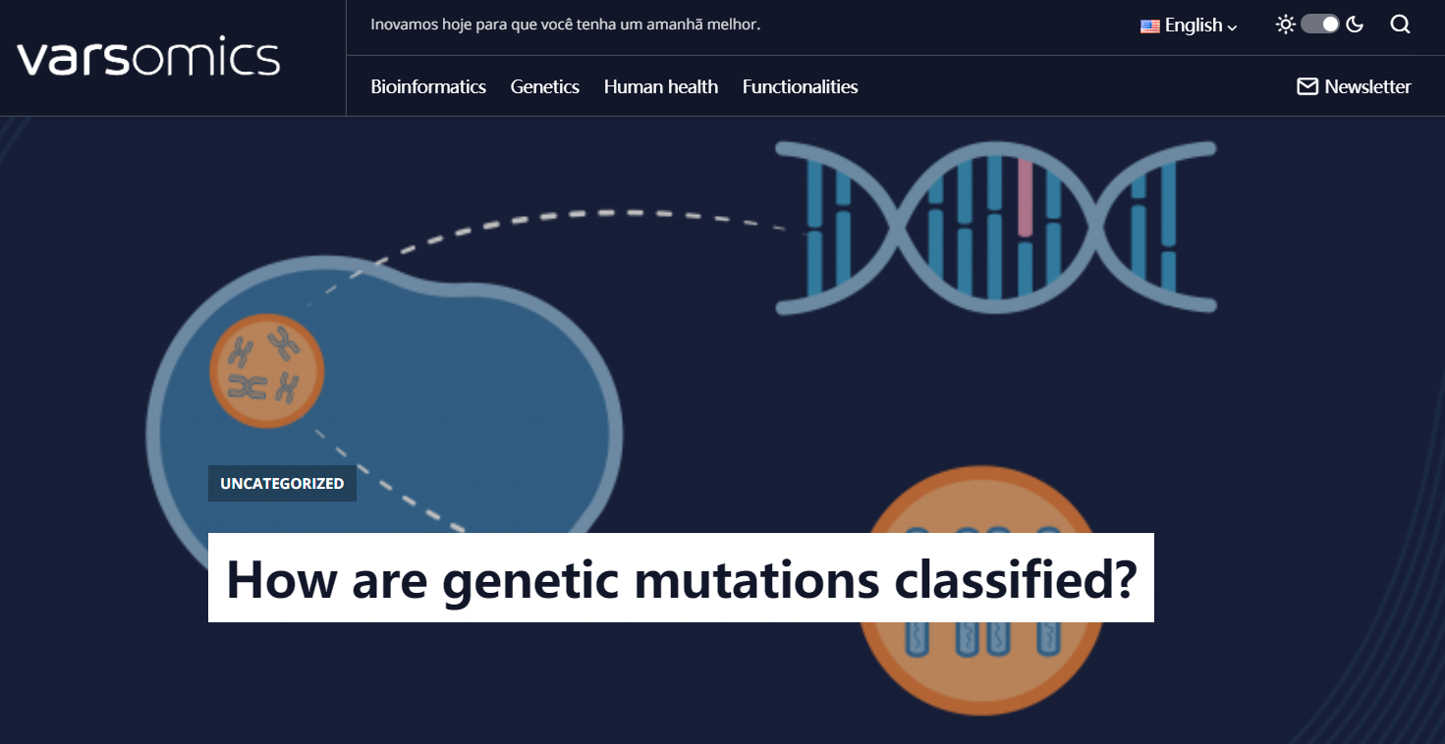

In the following topics we will briefly describe the different classifications of a variant. If you don’t know what mutations or genetic variants are, you should read the text [Mutation: the origin of genetic variation](https://varstation.com/articles/mutation-the-origin-of-genetic-variation/?__hstc=65185969.234016578a7fc630d493f8374763ce9f.1628067251709.1628129743972.1628685846438.4&__hssc=65185969.1.1628685846438&__hsfp=2303363933) first.

**Types of genetic mutations**

First, a variant can occur in only a few cells or tissues in an organism, and is thus called a **variant** or **somatic mutation.** However, it can also appear during embryonic development in cells of the reproductive lineage (in sperm or eggs) and is called a **variant** or **germline mutation.**

**Germline mutations** are transmitted to the offspring, giving rise to a new individual having all the cells with the mutation.

**Somatic mutations** can occur in any **cell division** from the first cleavage of the fertilized egg to the cell divisions that replace the cells of an adult individual. Somatic variants are not transmitted to the next generation (offspring), however, the cell with the mutation will transmit the change to all of its descendant cells.

**Somatic variants** are often caused by environmental factors, such as exposure to ultraviolet radiation or certain chemicals, and can lead to a lot of diseases, mainly found in **cancer.**

**形成原因**

Germline mutations 主要是由于生殖细胞（germ cells）突变导致，生殖细胞在男性中为精源细胞，突变发生在睾丸中；生殖细胞在女性中为卵细胞，突变发生在卵巢中。

Somatic mutations主要是由于体细胞（somatic cells）突变导致，皮肤，肝脏，骨髓，眼睛等的细胞均为体细胞，但不包含生殖细胞。

**遗传性**

Germline mutations 本质上是遗传性的，因为它们发生在参与受精的配子（ gametes）中。 因此，已经发生突变的亲本死亡将不会消除该突变，而是传递给后代。

Somatic mutations会传给daughter cells，一直存在直到它们最初发生的亲本细胞死亡或子细胞（如果有）死亡或生物体本身死亡为止。

**功能**

在大多数情况下，Germline mutations 是“沉默的”，不对亲本产生影响，除非它们影响配子（ gametes）的产生。 尽管这些突变会造成负面影响，例如罕见疾病，甚至癌症，但仍可促进人类健康的遗传多样性。

Somatic mutations仅仅在发生突变的细胞中起作用。 但是，在某些情况下，它们可能会显示有害影响，如对细胞造成损害，癌变或细胞死亡。

**发生时期**

Germline mutations发生在减数分裂的过程中，因为性细胞需要将其染色体分裂成两半，以便在受精过程中恢复原始的染色体数。 在精子中发生这种突变的可能性要比在卵子中发生的可能性高，因为前者形成过程中发生的细胞分裂数量要多于后者，这使得雄性的种系突变率更高。

Somatic mutations发生在有丝分裂期间，所有体细胞仅通过该过程分裂。 这是因为，有丝分裂产生的子细胞具有相等数目的染色体，这对于维持细胞中的人类染色体数目至关重要。

**mutation检测**

单有癌样本是无法区分Germline mutations和Somatic mutations的，只有加入健康样本才能过滤掉Germline mutations找出Somatic mutations。

**Mutations can be divided into two main categories**

* **Chromosomal alterations:**

affecting the number or structure of the cell’s chromosomes;

* **Gene alterations:**

mutations that occur in the DNA sequence.

***NOTE:****The human genome consists of 46 chromosomes: 2 sets of 22 autosomal homologous chromosomes and 2 sex chromosomes, X and Y. Half of the chromosomes are inherited from the mother and the other half from the father. Chromosomes have two segments, called “arms”, separated by a compressed region known as a centromere. The shortest arm is called the “p” arm. The longest arm is called the “q” arm.*

**Chromosomal mutations**

There are several types of chromosomal mutations, in general, we can organize them into two basic groups: **numerical and structural alterations**.

**Numerical chromosomal mutations** are alterations that **affect the number of whole chromosomes** (euploidies), increasing (polyploidy) or decreasing (haploidy or monoploidy) their **total set**, or they can change the number of **specific isolated chromosomes** (aneuploidies) (eg, trisomy of the chromosome 21, known as Down Syndrome).

**Structural chromosomal mutations** are changes that involve the structure (shape or size) of a chromosome.

<https://www.yourgenome.org/facts/what-is-a-chromosome-disorder>

* **Inversion:** a part of the chromosome broke, turned upside down and joined again.
* **Translocation:** a portion of a chromosome is transferred to another chromosome. There are two main types of translocations：

1. **Reciprocal translocation:** segments of two different chromosomes were exchanged.
2. **Robertsonian translocation:** two whole chromosomes are joined by the centromere.

* **Deletion:** a part of the chromosome has been lost.
* **Duplication:**a part of the chromosome was folded, resulting in extra material.
* **Ring chromosome:** the ends of a chromosome fuse to form a circular or ring-shaped chromosome. This can happen with or without loss of genetic material.
* **Isochromosome:** one arm of a chromosome is missing and the remaining arm is duplicated.

If the chromosome set is complete, even if reorganized in the wrong way, the change is called **balanced.** If there are additional or missing parts it is called **unbalanced.**

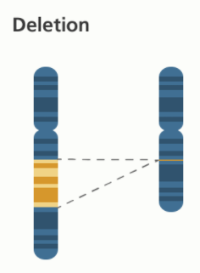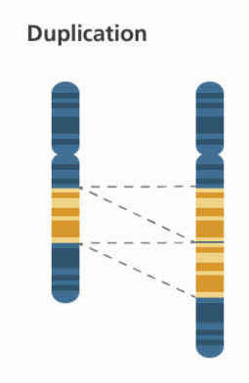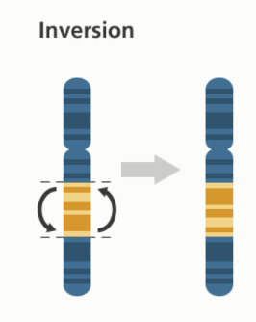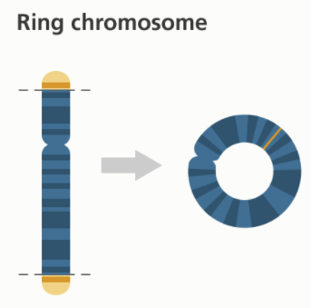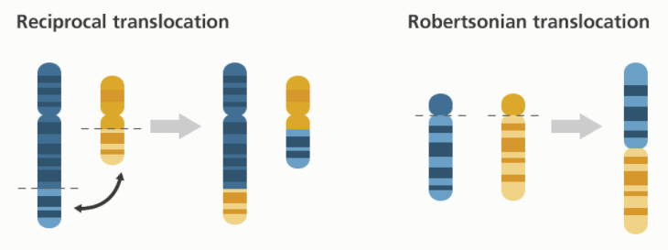

**Gene mutations**

Gene mutations are changes in the DNA sequence that can involve from a single nucleotide to a few base pairs. The genetic alterations can be of the type:

**Point mutations or single nucleotide substitutions:**replacement of a base pair of DNA.

* **Missense/meaning exchange mutations/not synonymous:** alteration in a base pair of DNA that results in the substitution of one amino acid for another in the protein produced by a gene.
* **Synonymous or silent:** change in a base pair of DNA that changes the codon to another that encodes the same amino acid and does not cause changes in the protein produced.
* **Nonsense/meaningless mutations:** change in a base pair of DNA that prematurely signals the end of a protein. This type of mutation results in a reduced protein that may work improperly or not at all.

**Nucleotide insertions or deletions (indels):**

* **Insertion:** addition of one or more nucleotides to the DNA sequence.
* **Deletion:**removal of one or more nucleotides from the DNA sequence.
* **Duplication:** A duplication consists of a piece of DNA that is copied abnormally one or more times.

**Reading frame change/frameshift mutation:** This type of mutation occurs when the addition or removal of DNA bases **alters the reading structure of a gene**. A reading frame consists of groups of 3 bases (codon) that code for an amino acid.

A frame-changing mutation alters the grouping of these bases and changes the amino acid code. The resulting protein is generally non-functional. **Insertions, deletions and duplications can be frameshift mutations.**

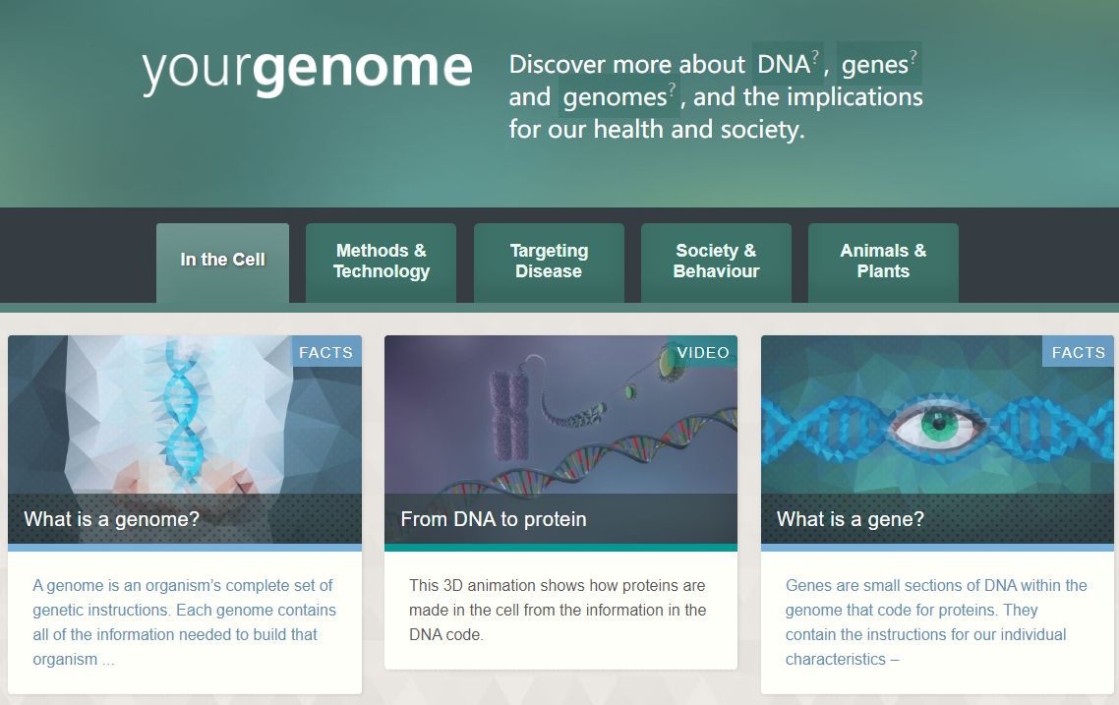

https://www.yourgenome.org/